Ex. No. 5 | JAVASCRIPT - DOM ELEMENTS AND EVENTS
Date of Exercise | 21.08.2026
GitHub Host Link | https://jinto-joseph.github.io/WEB_TECH_LAB/21_Aug_2026/index.html

Aim
To create web pages which demonstrate the applications of document object model and events in JavaScript.
Description
Document Object Model:
A Document object represents the HTML document that is displayed in that window. The Document object has various properties that refer to other objects which allow access to and modification of document content. The way a document content is accessed and modified is called the Document Object Model, or DOM.
Finding HTML Element by Id
var myElement = document.getElementById("intro");
Finding HTML Elements by Tag Name
var x = document.getElementsByTagName("p");
Finding HTML Elements by Class Name
var x = document.getElementsByClassName("intro");
Finding HTML Elements by CSS Selectors
var x = document.querySelectorAll("p.intro");
Attach event handler to the document
document.addEventListener("click", function()
{
document.getElementById("demo").innerHTML = "Karunya";
});
JavaScript Events:
JavaScript's interaction with HTML is handled through events that occur when the user or the browser manipulates a page.
Event | Description
onabort | Triggers on an abort event.
onblur | Triggers when the window loses focus.
onchange | Triggers when an element changes.
onclick | Triggers on a mouse click.
ondblclick | Triggers on a mouse double-click.
ondrag | Triggers when an element is dragged.
onfocus | Triggers when the window gets focus.
onkeyup | Triggers when a key is released.
onload | Triggers when the document loads.
onkeydown | Triggers when a key is pressed.
onkeypress | Triggers when a key is pressed and released.
onmousedown | Triggers when a mouse button is pressed.
onmousemove | Triggers when the mouse pointer moves.
onmouseout | Triggers when the mouse pointer moves out of an element.
onmouseover | Triggers when the mouse pointer moves over an element.
onmouseup | Triggers when a mouse button is released.
onresize | Triggers when the window is resized.
onscroll | Triggers when an element’s scrollbar is being scrolled.
onsubmit | Triggers when a form is submitted.
onunload | Triggers when the user leaves the document.

Sample Questions:
1. Write a function that accepts a string as a parameter and find the shortest and longest word within the string. Example string: 'Web Development Tutorial'
Expected Output: Shortest: 'Web'
Longest: 'Development'
Hint: Split a string into an array - split()
Find the length of a string - stringname.length
Find the size of an array - arrayname.length
Program
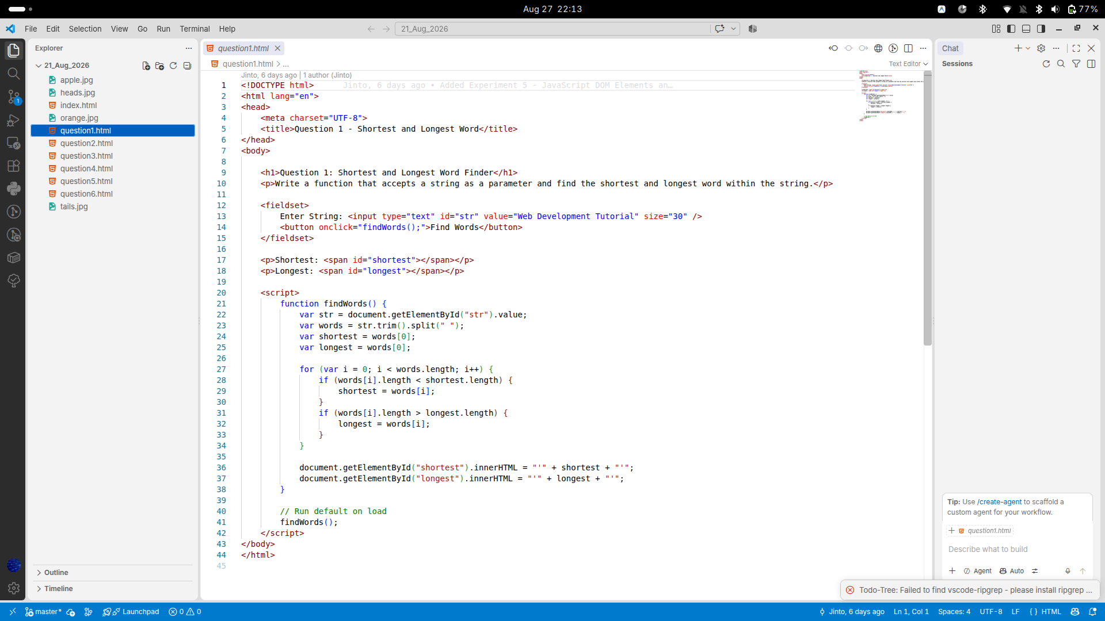
Output
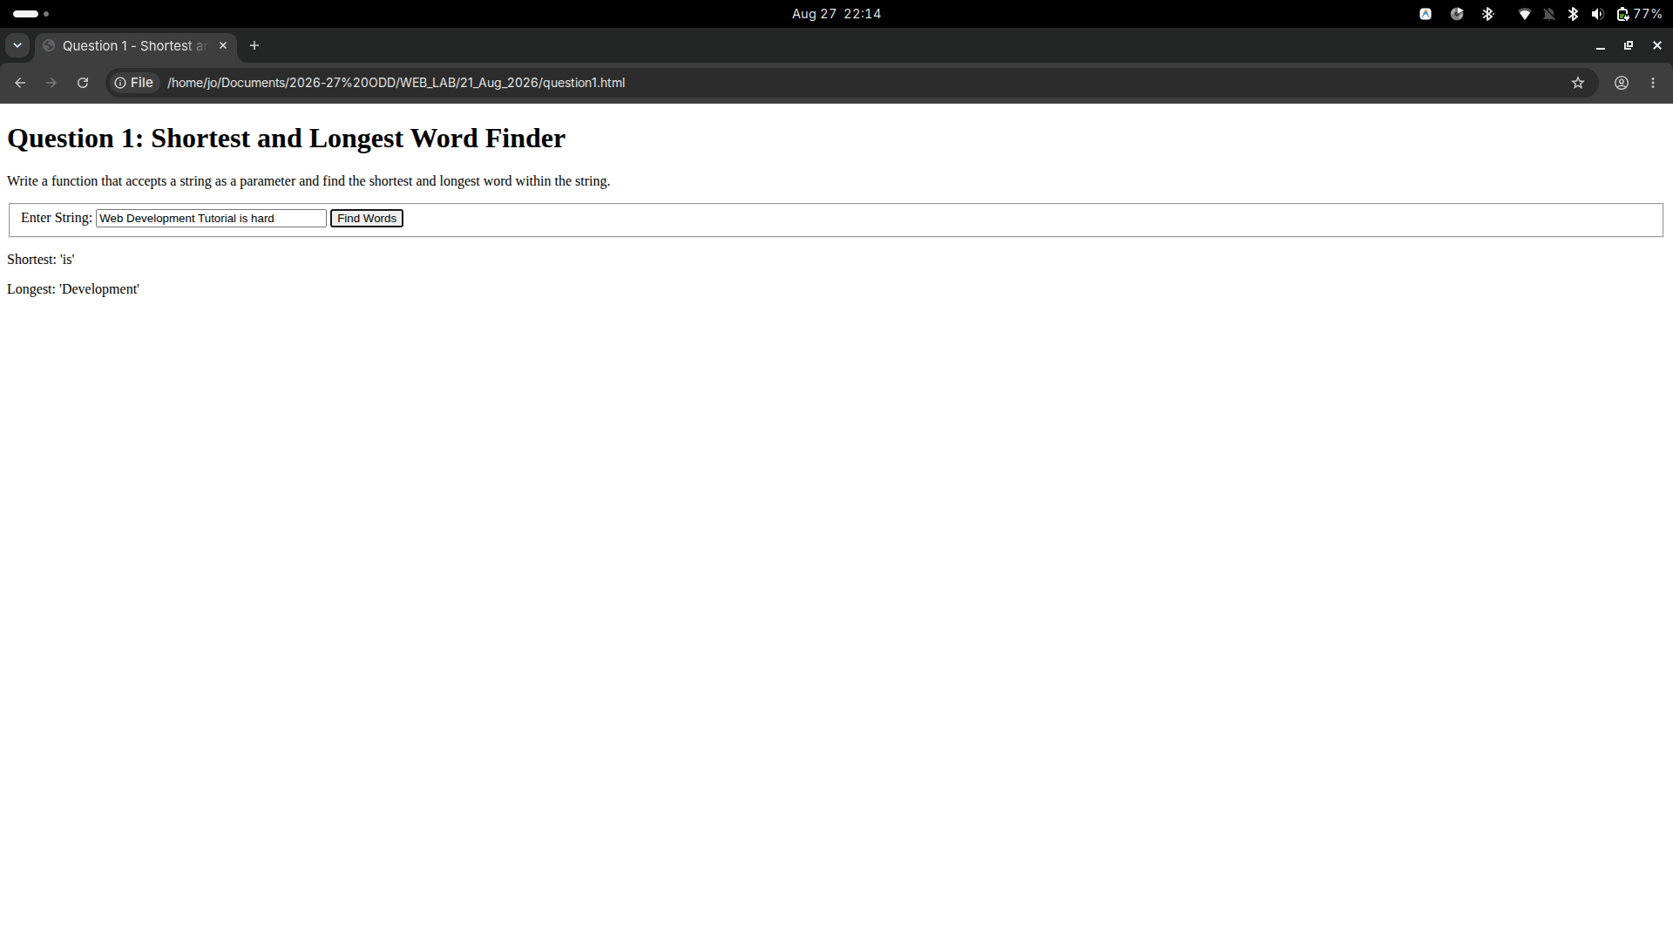
2. BMI Calculator:
The following HTML snippet shows the skeleton of a BMI calculator. Write the calculate() function that takes the weight and height in the text boxes and displays the BMI in the span with the id of “score”. BMI is calculated from the equation: weight / (height * height). You should also describe the person's body type based on their BMI score using the following criteria:
- Underweight: < 18
- Normal: 18 - 25
- Overweight: 25-30
- Obese: > 30
The person's body type should be displayed in the span with the id of "type" and you may assume valid input into the text boxes.

<h1>Calculate your Body Mass Index (BMI) !< /h1>
<fieldset>
Weight (in kilograms): <input type="text" id="weight" /><br />
Height (in meters): <input type="text" id="height" /><br />
<button onclick="calculate();">Get BMI !< /button>
</fieldset>
<p>
Your BMI is <span id="score"></span>. <br />
Your body type is <span id="type"></span>.
</p>

function calculate () {
//extract data from input box
var height = parseFloat(document.getElementById("height").value);
//change the content of html element
document.getElementById("score").innerHTML = bmi;
}

Program
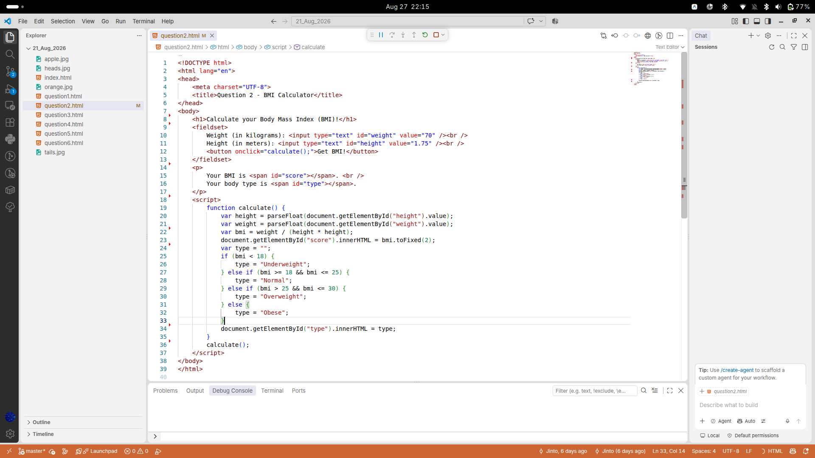
Output
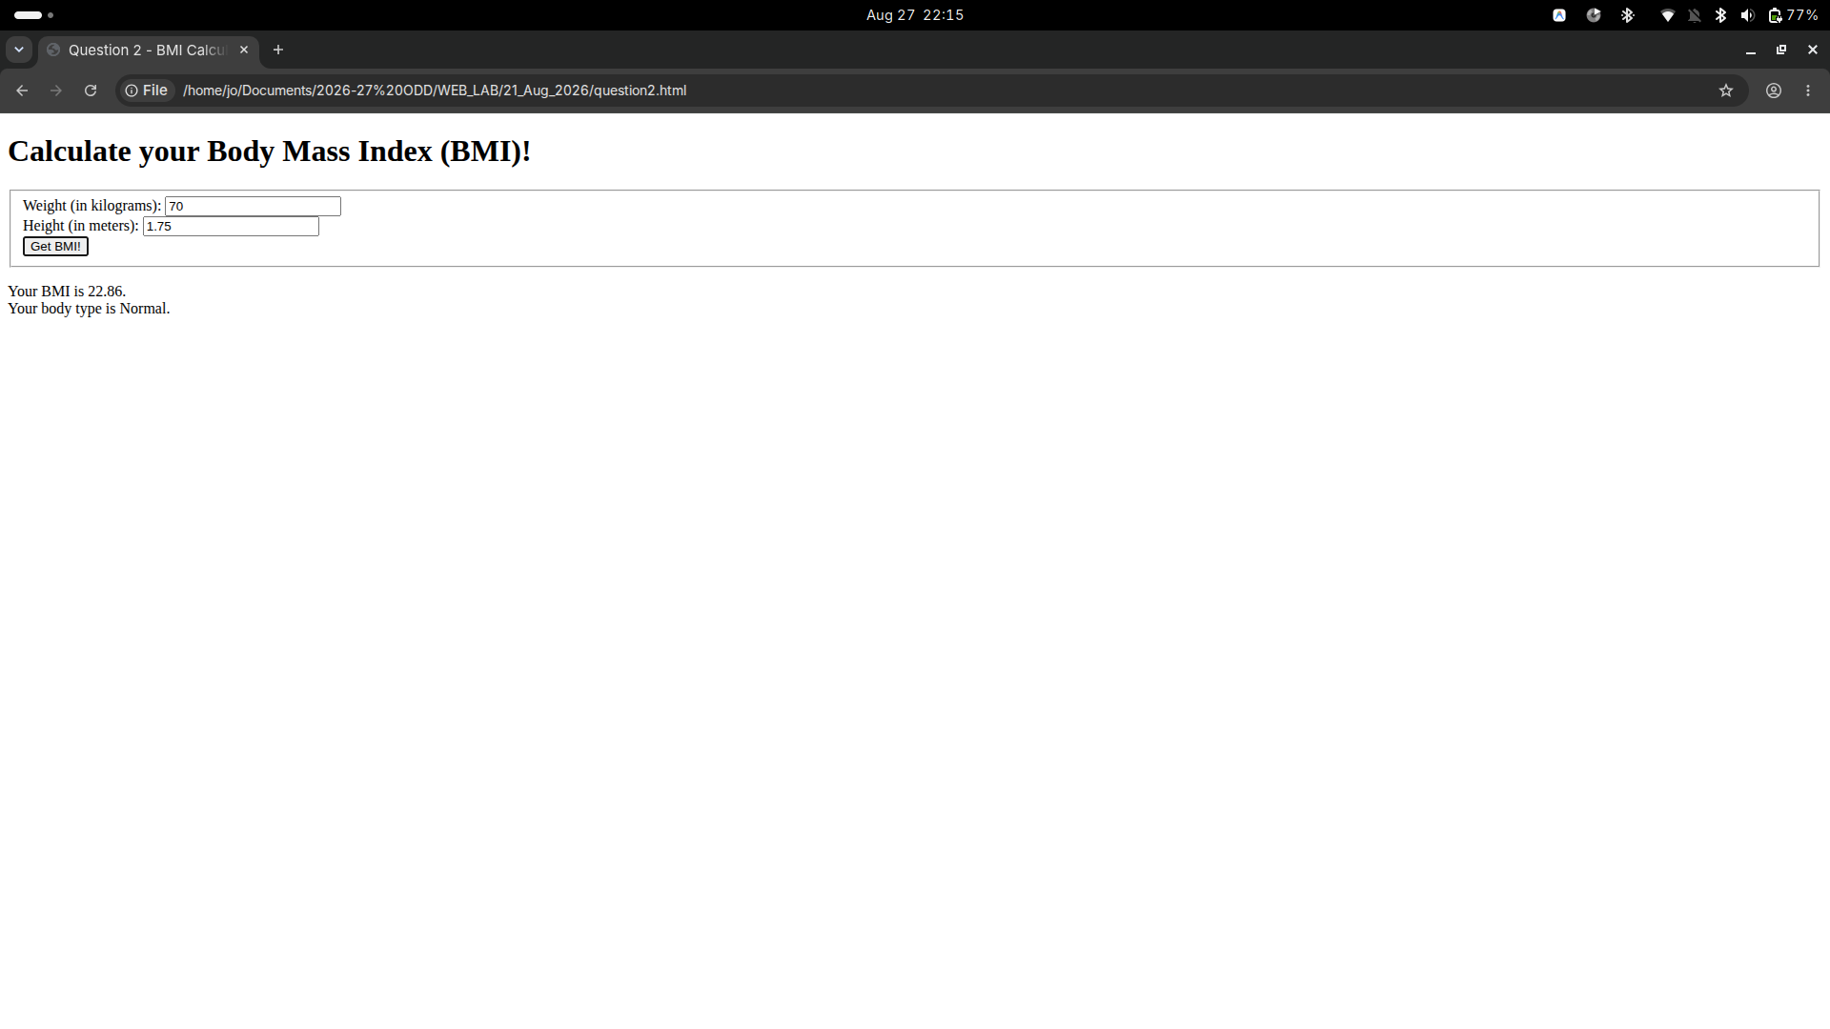

3. Fruit Farm:
The following HTML snippet is from a webpage that allows users to design rectangular fruit farm beds. When you click the "Plant Garden" button, the page should generate a rectangular grid of fruit images in the div with the id of “garden.” The dimensions of grid are given by the values entered in the text boxes. Write the grow() JavaScript function to complete the functionality for the webpage. You should randomly display either "apple.jpg” or “orange.jpg” for each fruit image, and either fruit should show up with equal probability.

<h1>Fruit Farm</h1>
<div>
Rows: <input type="text" id="rows" />
Columns: <input type="text" id="columns" /> <br />
<button onclick="grow();">Plant Garden</button>
</div>
<div id="garden"></div>

//add image
document.getElementById("garden").innerHTML +="<img src= Apple.jpg width =100px height=100px>"; // += for appending the text
// create an array of strings
var arr = ["Orange.jpg","Apple.jpg"];
//generate random number in the range of 0 to 10
var number = Math.floor((Math.random() *upper bound) +lower bound);

Program
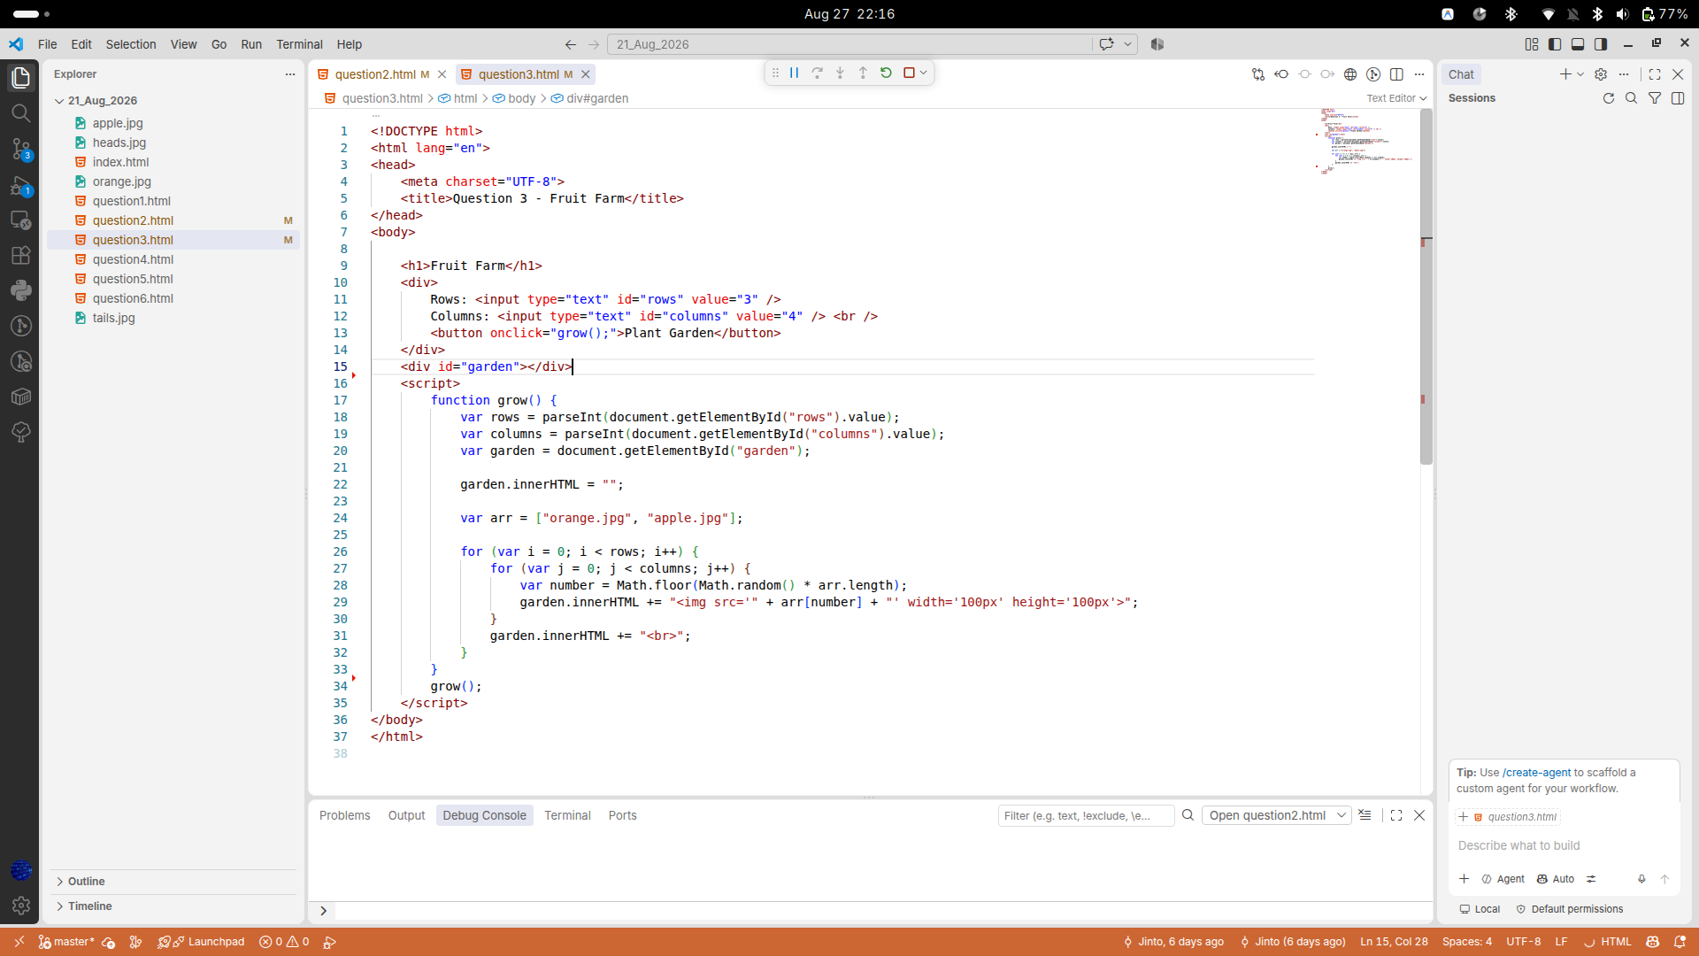
Output
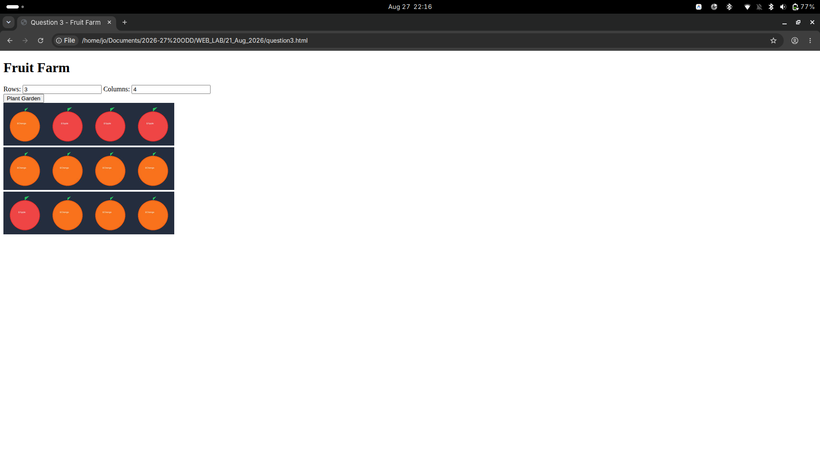
4. The Currency Convertor:
The following HTML snippet shows the skeleton of a rupees-to-dollars, dollars-to-rupees conversion tool. Write the convert() function that takes the value in the text input and converts it from the unit selected in the left dropdown box to the unit selected on the right. The unit should be displayed in the empty span with the id of “answer.” The conversion factor from rupees to dollars is 0.015, and the conversion factor from dollars to rupees is 67.12. You should edit the HTML to add ids to the elements as necessary and you may assume valid input.

<fieldset> Convert <input type="text" id="data" />
<select id="from">
<option>Indian Rupee</option>
<option>US Dollar</option>
</select>
to
<select id="to">
<option> US Dollar </option>
<option> Indian Rupee </option>
</select>
<button
onclick="convert();">Calculate</button>
id="answer"></span>
</fieldset>

//extract value from drop down list
var index = document.getElementById("from").selectedIndex; // return index
var value = document.getElementById("from")[index].value; // return value

Program
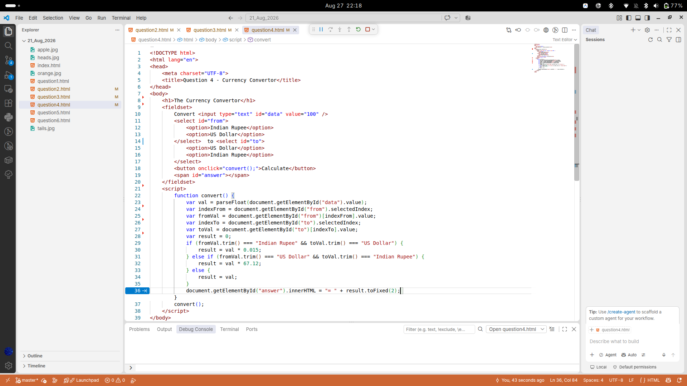
Output
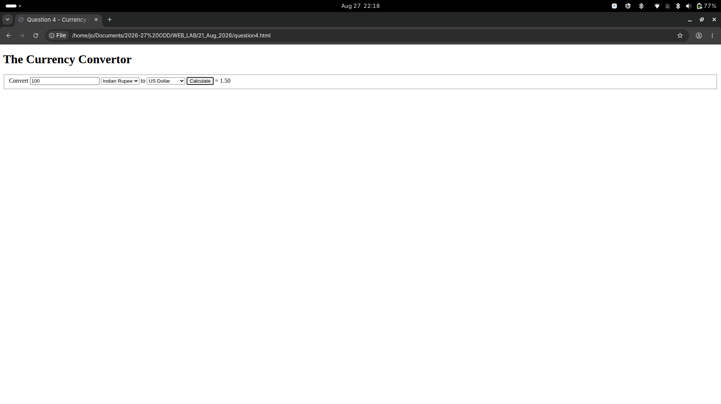

5. Coin Flip:
Write JavaScript code to randomly change the src of the img in the HTML snippet to "heads.jpg" or "tails.jpg" when the "Flip!” button is pressed. The image should change to the heads or tails picture with equal probability. Keep track of how many flips have resulted in heads and tails and report the results beneath the button in two spans with ids "num_heads" and "num_tails" respectively. You should write JavaScript code to attach the event handler to the button and you may assume the user enters valid input.

<h1>Heads or Tails?</h1>
<div>
<img src="heads.jpg" id="coin" /> <br /> <button id="flip">Flip!</button>
</div>
<p>
Heads Total: <span id="num_heads">0</span><br />
Tails Total: <span id="num_tails">0</span>
</p>

// attach the event handler to the button
document.getElementById("flip").addEventListener("click", flipFunction);
function flipFunction() {
//code goes here
}
// change the src of the img in html
document.getElementById("coin").src ="head.jpg";

Program 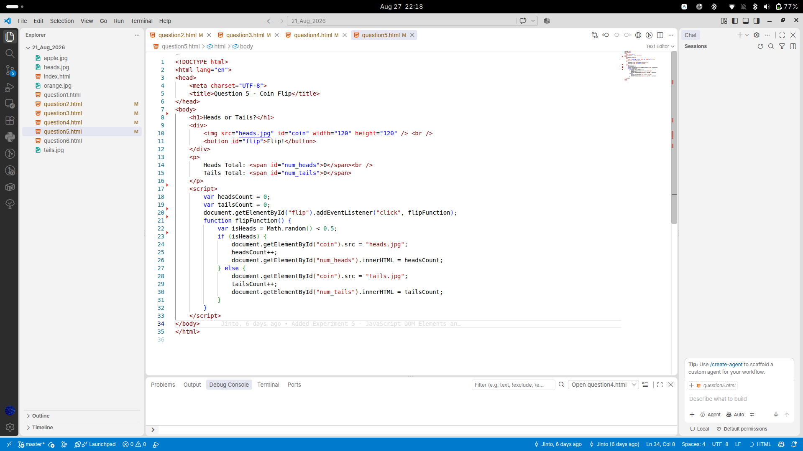
Output
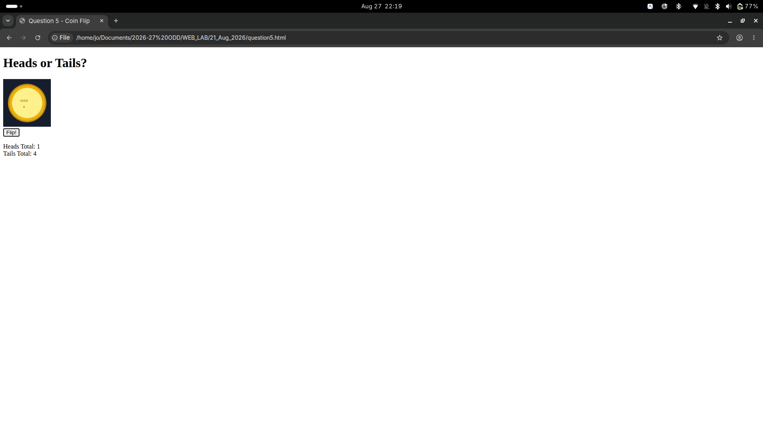
6. Birthday Cake Order Form:
The following HTML snippet represents a skeleton of a price calculator for a cake order form. A 1/2kg cake is Rs.100, a 1kg cake is Rs.200 and a 2kg cake is Rs.400. Tax is an additional 9% to the order. The user must also pay a tip from 10-20% of the total cost of the order after tax. Write the JavaScript code necessary to calculate and display the total cost of the order in the span with the id of "price" when the user clicks the "Calculate Order" button. You should write unobtrusive JavaScript code to attach the event handler to the button and you may assume the user enters valid input.

<h1>Pizza Order Form</h1>
<fieldset>
# of 1/2kg Cakes <input type="text" id="small" /><br />
# of 1kg Cakes <input type="text" id="medium" /><br />
# of 2kg Cakes <input type="text" id="large" /><br /> Tip:
<label><input type="radio" value="10" name="tip" /> 10%</label>
<label><input type="radio" value="15" name="tip" checked="checked" 15% </label> <label><input type="radio" value="20" name="tip" /> 20%</label> <br />
<button id="submit">Calculate Order</button> </fieldset>
<p>
Cost of order: <span id="price"> </span>
<p>

//extract value from radio buttons
document.querySelector('input[name="tip"] : checked").value

Program
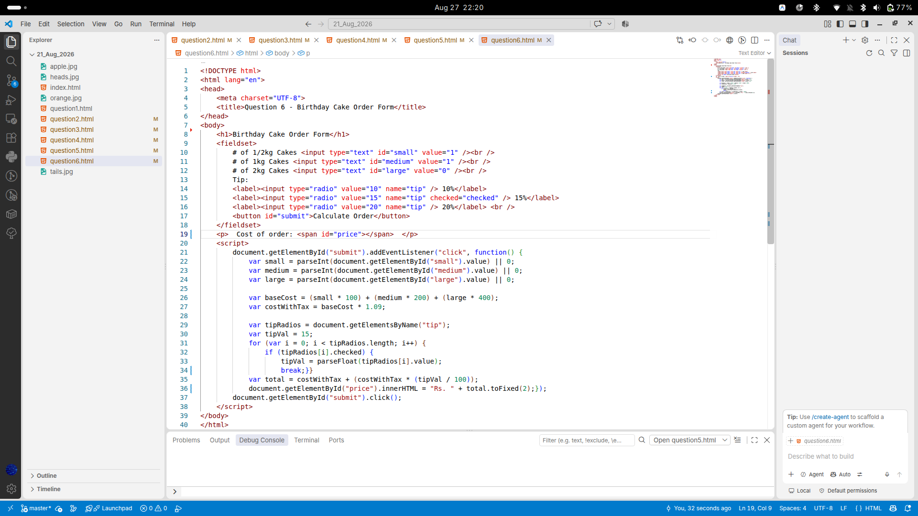
Output
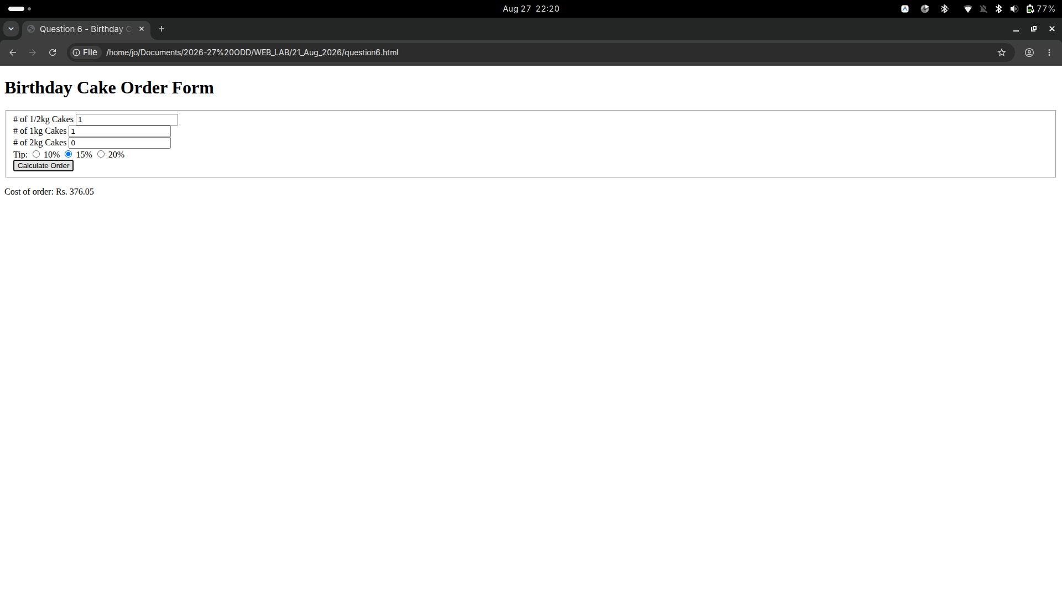

Result
Thus, the JavaScript DOM Elements and Events programs were successfully executed. The programs demonstrated DOM manipulation, event handling, input processing, random values, calculations, and dynamic changes to HTML elements.

